We will discuss about payment gateway system which you can plug and play in other application like Uber, Zomato etc
Requirements:-
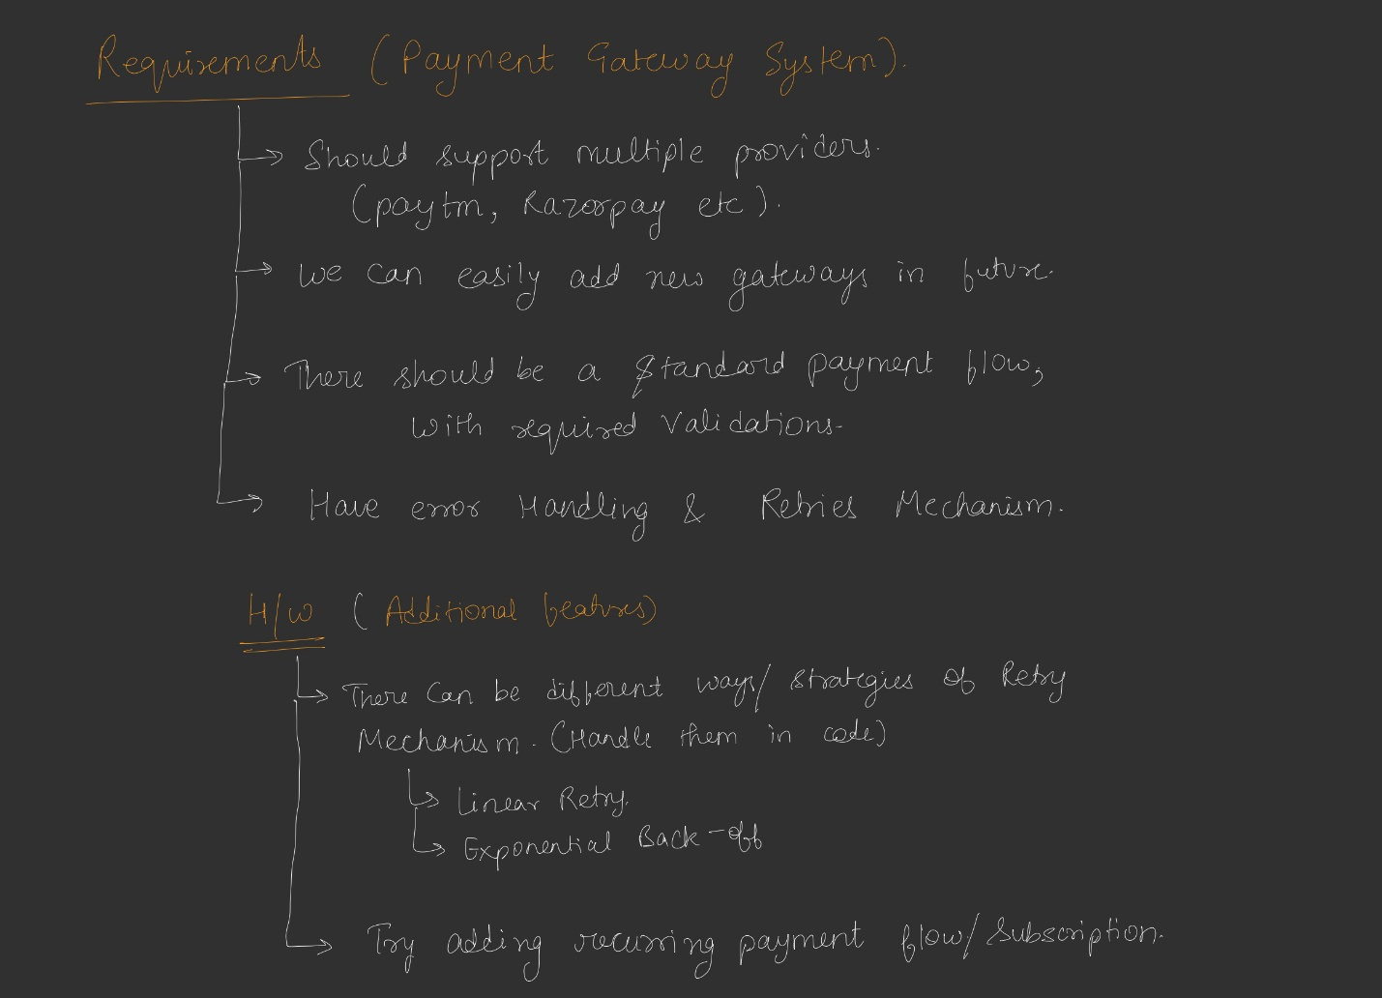
Standard payment flow – first it should validate()-user has sufficient fund or not, request is valid or not
Second actual payment will initiate() – here we will say paytm or razorpay to actually do the payment and it response us with True or false
Confirmation
For standard payment flow we can use Template pattern
Happy flow
Client request a payment request with info regarding sender, receiver, amount then this request is full filled by a class called Gateway-there can be different gateways like paytm, Razorpay and in future we can integrate more gateways. These gateways over the internet talks with their banking system and finally return true or false to the client
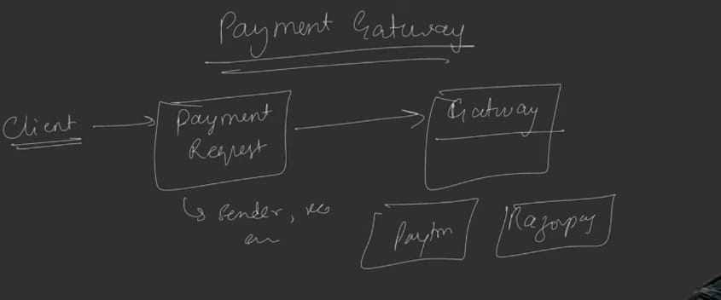
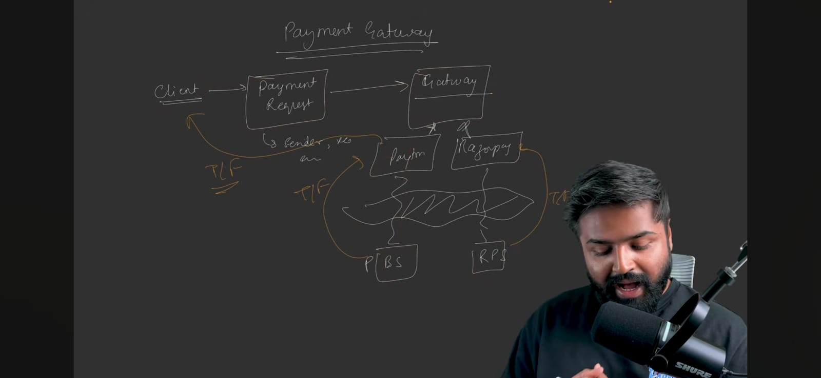
Now let’s understand what gateway means
Suppose we have application and there is small border in our application. Border to external world like internet i.e. if you want to do any external call from our application like http call. The layer/classes from which our all call going outside is called gateway.
You can imagine there is a banking system outside to which our payment gateway interacts and give response back to the application

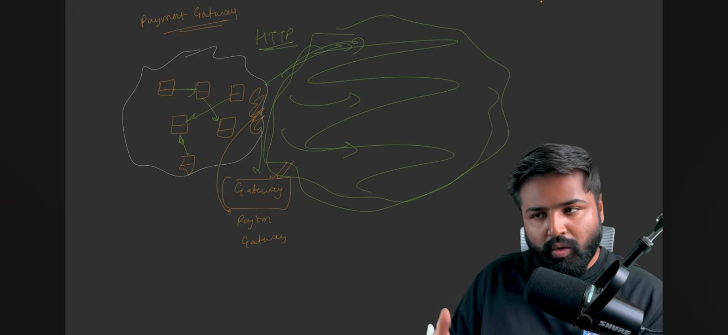
UML Diagram
Let make payment request Object. It will be a model class which contains basic things and getter and setter
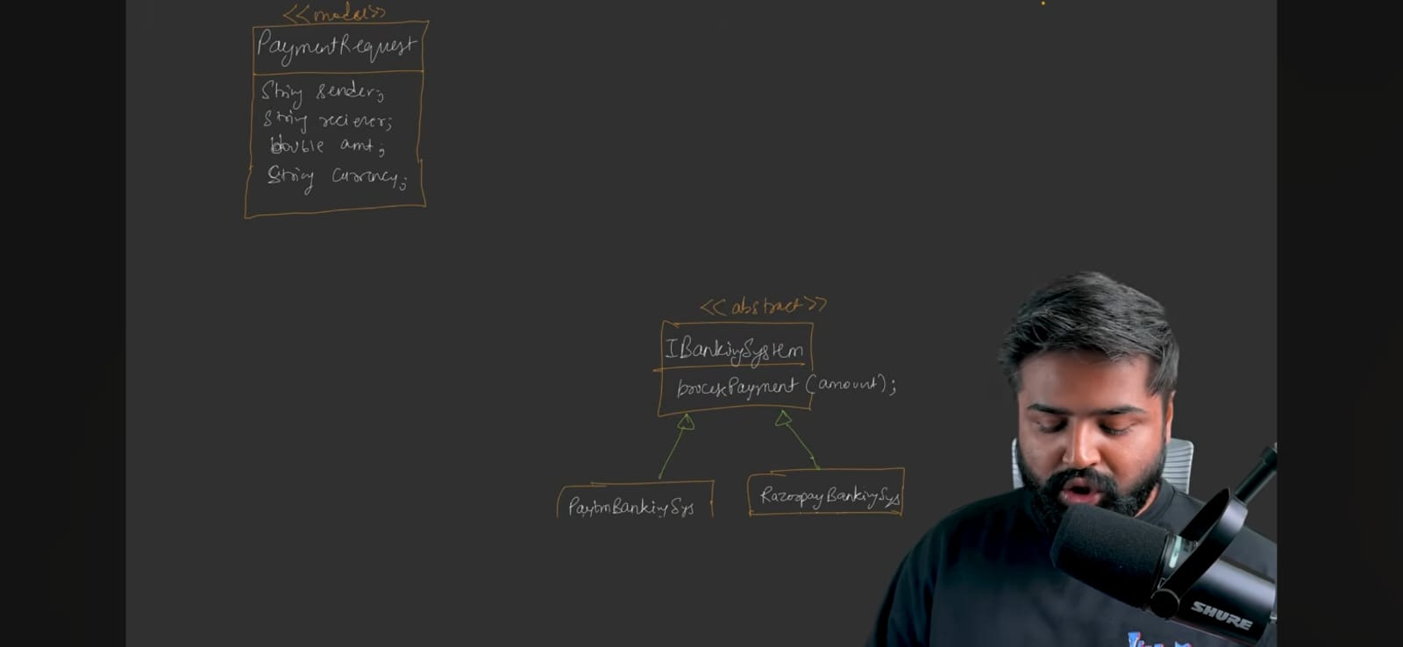

Now let’s make a Interface of Banking system where we actually send the request at last. We will not go deep inside it. It just have the method called processPayment(amount) which just return the Boolean weather the payment done or not.
For now let’s create 2 concrete object for that paytm and Razorpay.
We are assuming this below hierarchy of Banking System is already provided we just need to pass the object through which we want to do the payment like paytm or razorpay and payment will happen automatically.
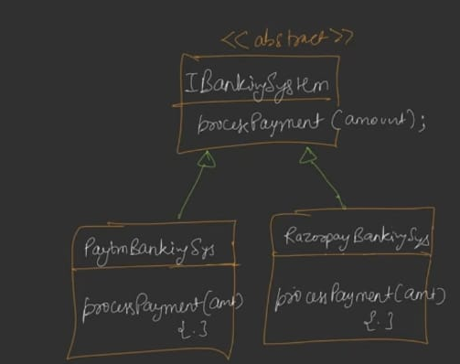
Now to join both Request model and banking System we need gateway. Let’s make that
We can’t directly have the object of IBankingSystem object in our paymentGateway class because banking system is on different server not in our application so paymentGateway can talk with banking system via internet or some API calls.
For that need a proxy of IBankingSytem in our application which will actually talk to actual IBankingSystem
But for now we are not making a proxy as it will be complex. For now suppose gateway will have a object of IbankingSystem which actually talk to IBankingSystem class through proxy only in the background
PaymentGateway will have the object of PaymentRequest as well. And we know to process the request in particular order we use template pattern. So for that we have method – processpayment() , and validate(), intiate(), confirm().
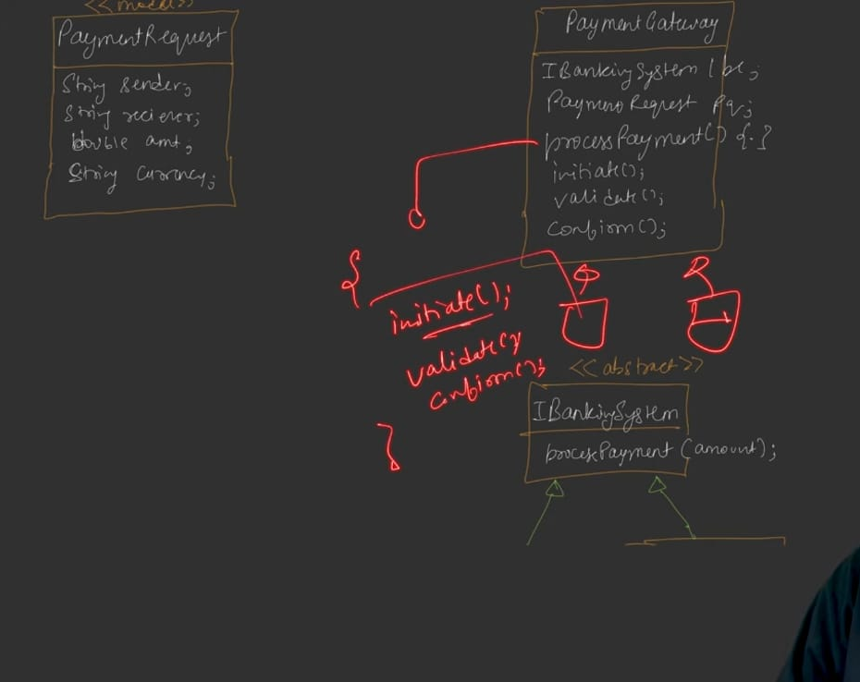
Let’s make child classes of Paymentgateway which defines initiate(), validate(), confirm(). But they will be called in order and order is decided by processpayment() {} in PaymentGateway interface
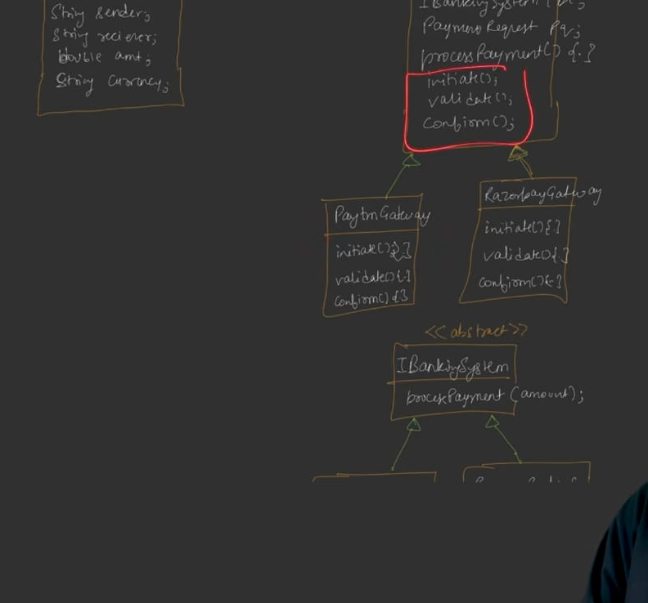

Now paytmGateway or RazorpayGateway will have the object of PaytmbankingSystem or RazorpayBankingSystem. Yes still you can defend yourself by saying we will have the object of proxy which calls these actual bankingSystem’s object. OR you can say this IBankingSystem hierarchy is itself a proxy which talks with the actual banking system on different server
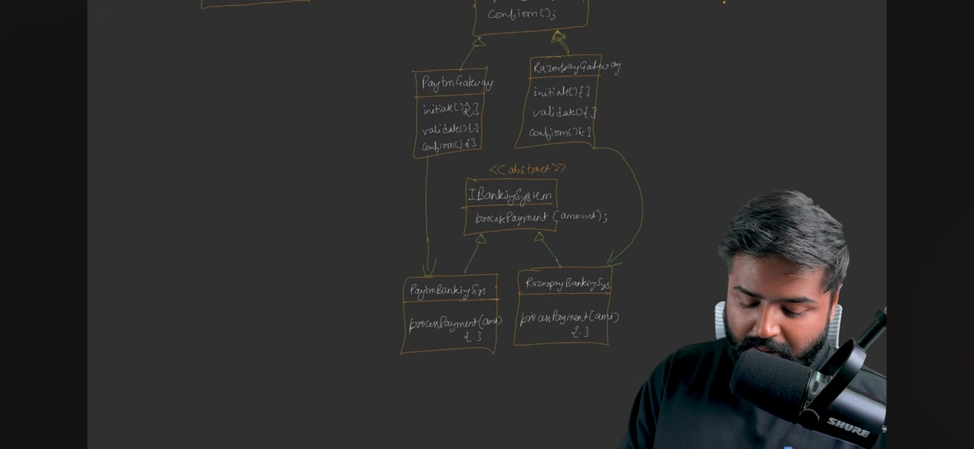
If we are considereing IBankingSystem as a proxy itself then without gateway proxy can’t exist. Therefore It has strong composition relationship
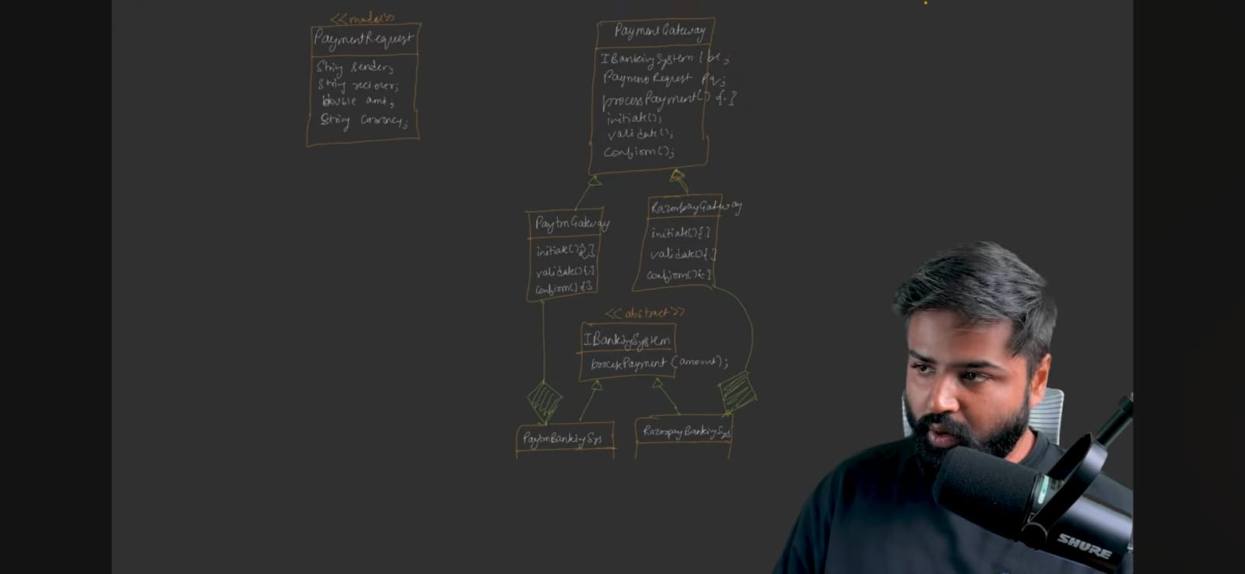
Let’s integrate retry mechanism
For retry mechanism we will use Protection Proxy pattern whose work is simple to dedicate the work to real object and retry mechanism will be done in code of proxy
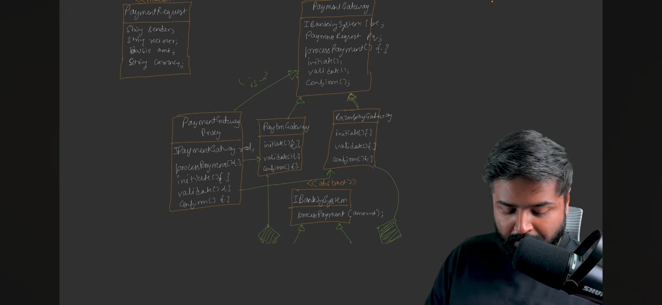

Now to create Paytm gateway, Razorpay gateway and PaymentGatewayProxy we have create factory. Eventually we will return the PaymentGatewayProxy but in that we will inject the object of real Payment Gateway i.e. Paytm gateway or Razorpay gateway in “real” object – that we will see in code.
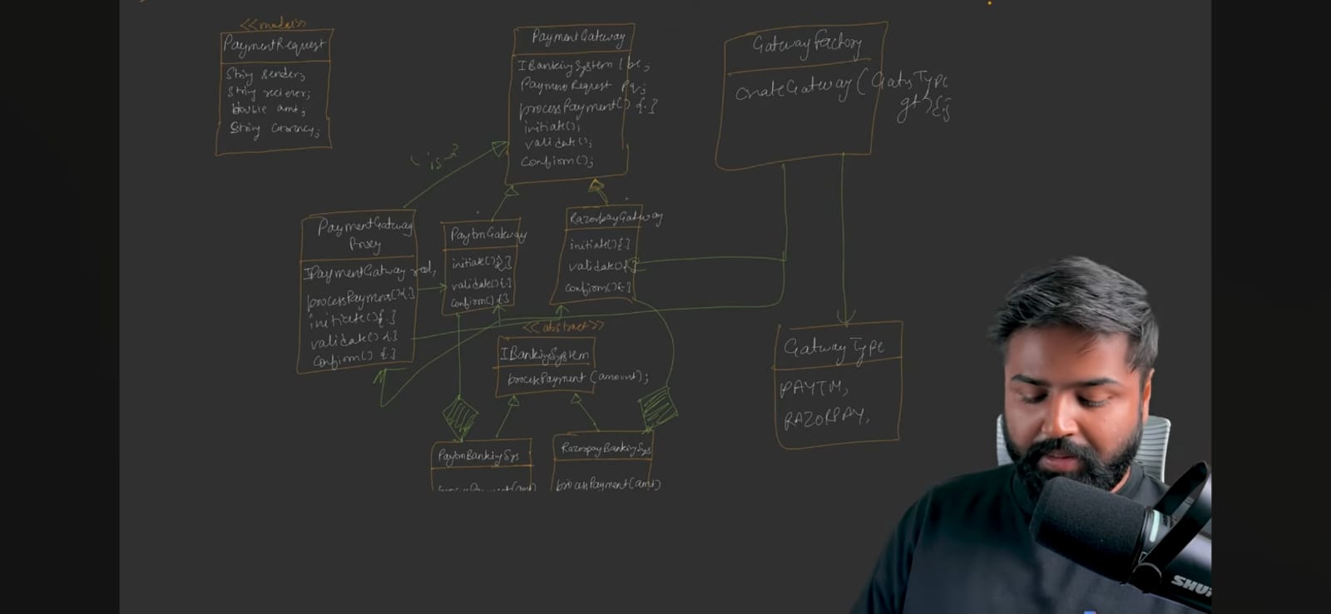
Now to call this all classes we should have a service class
Create it:-
Payment Service will have the object of Payment Gateway
Every call will go through this “PaymentService” class only. Create a controller layer “PaymentController” – this controller will be the entry point which only talks with service and service talks to whole hierarchy of classes
We could have make only service layer not controller but we want controller just to redirect the request and service layer will handle the business logic
Service will have the processPayment() method which basically call the processPayment of PaymentGateway only
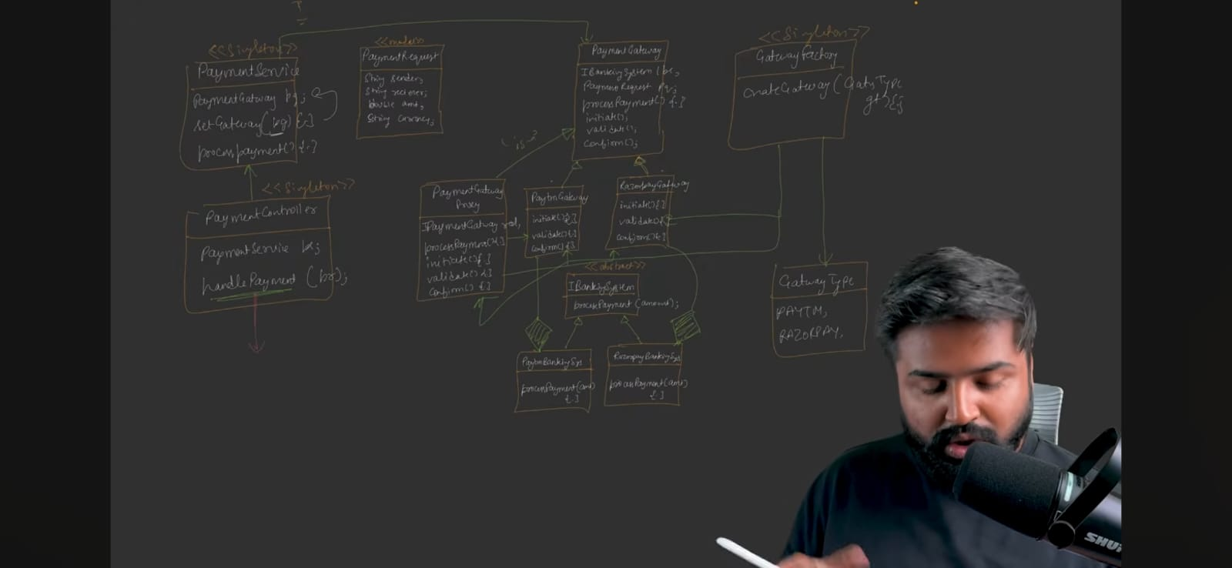

Code inside controller’s handlepayment(){
Pg = GatewayFactory::getInstance(PAYTM); // this give you paytm type gateway injected the proxy, means at last you get the proxy object
Ps.setGateway(pg);
Ps.processPayment();
}
Code of service’s processPayment(){
Pg.processpayment(); //means proxy’s processPayment() is called which will validate(), initiate(), confirm()
}
Depends upon which “real” object is there “PaytmGateway” or “RazorpayGateway”, respective validate(),initiate(), confirm() will be called
Validate() will call its respective BankingSystem’s processPayment() which will return either true or false
Clean UML Diagram:-
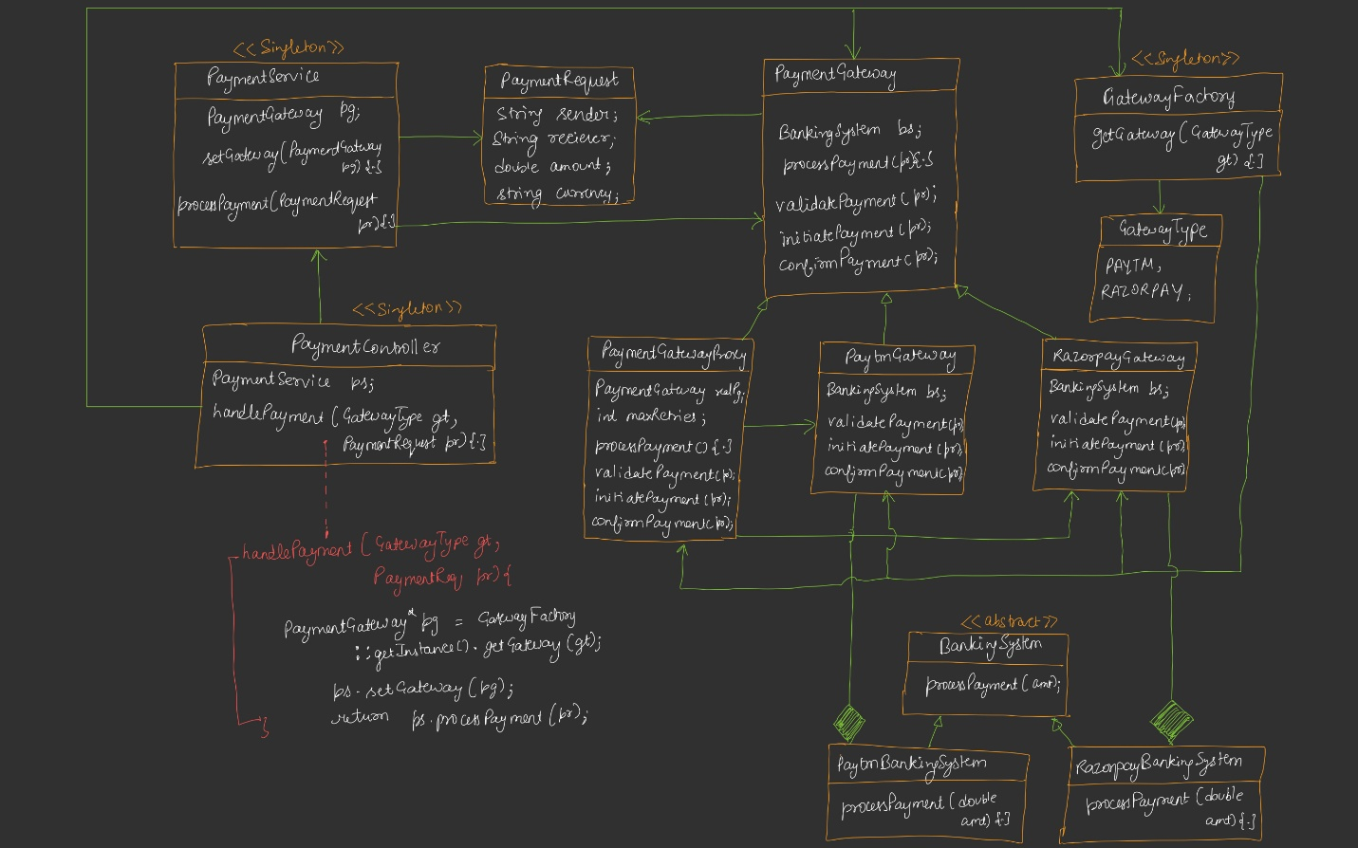
Code …see notes

